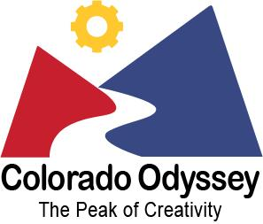
Odyssey of the Mind
Information Night
Bennett Elementary-Rm 20
Tuesday October 11th, 6:00-7:00pm

Colorado Odyssey of the Mind, 39 years of combining STEM with the Creative Arts!

Odyssey of the Mind is an extra-curricular school activity centered on creative problem solving that is modeled after interscholastic sports. Odyssey of the Mind’s creative competitions achieve the excitement of athletic competition, utilizing fun-filled and often-clever mental gymnastics. Teams match wits and abilities at local, state, and world competitions.

What: Odyssey of the Mind – Informational Meeting
When: Tuesday October 11, 2022 6:00-7:00pm
Who: Previous and new families interested in Odyssey of the Mind.
Kids are welcome!
At the meeting we will:
- Explore the Odyssey of the Mind (OM) program and its benefits for our students.
- Show you examples of typical OM problems. Bring your students so they can see how fun OM is!
- Review important dates, costs and time commitment.
- Give you insight on what coaching a team looks like and the resources available to help.
- Answer any questions you might have.
- Help you network to start organizing teams and identify coaches.
The Poudre River Regional Director will join us to answer questions as well.
Odyssey of the Mind is an all-volunteer organization. As such, the number of teams we have is only limited by the number of parent volunteers we have to coach. Join us at the meeting to find out more about coaching and the resources available.

The deadline to sign up and submit registration and payment is October 20, 2022.

For more information, check out coloradoodyssey.org and follow on Facebook @coloradoodyssey

If you are interested but can’t attend, let me know and I will keep you in the loop.

Alisa Keyser (she/her) - parent
Odyssey of the Mind Building Coordinator
Bennett Elementary, an IB World School
arkeyser@gmail.com
406.360.5830

